**Transactions in Hive**

**NOTE: Before working in hive shell, start all hadoop daemons using start-all.sh command, and start mysqld service using sudo service mysqld start, then launch hive using hive command.**

**Below steps are followed to work with transactions in Hive:**

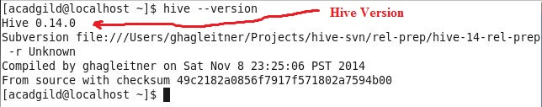**Step 1: Check hive version, using following command:**

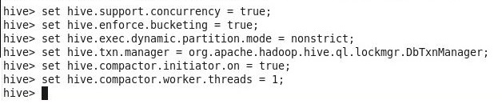

**Step 2: Below properties are set order-wise in order to work with transactions in Hive:**

**Step 3: Creation of table that supports Hive transactions**

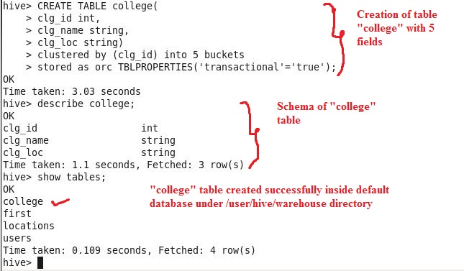

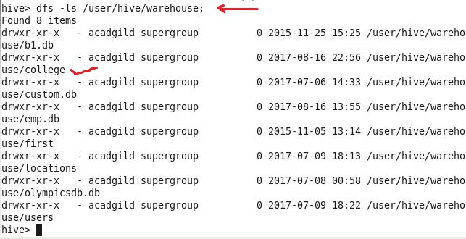

**Using above command besides “show tables” command, we can check “college” table is created successfully inside “/user/hive/warehouse” directory.**

**Explanation of “create table” command:**

The above syntax creates a table with name ‘*college’* and the columns present in the table are ‘*clg_id, clg_name, clg_loc’.* Table is being *bucketed* by ‘*clg_id’* and the table format is ‘*orc’,* also transactions in table are enabled by specifying *‘transactional’=’true’* inside the *TBLPROPERTIES*.

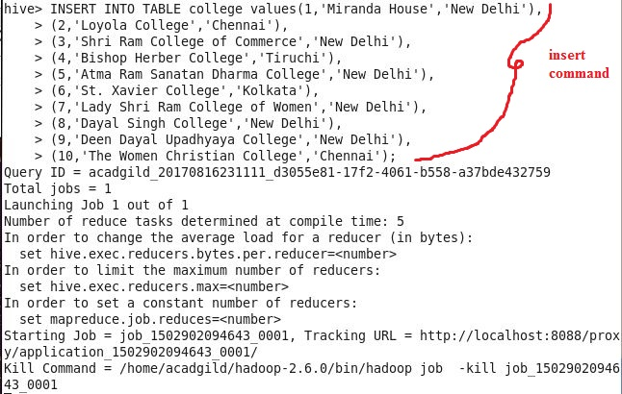**Step 4: Inserting Data “row-wise” (each row separated by ()) into Hive Table “college”**

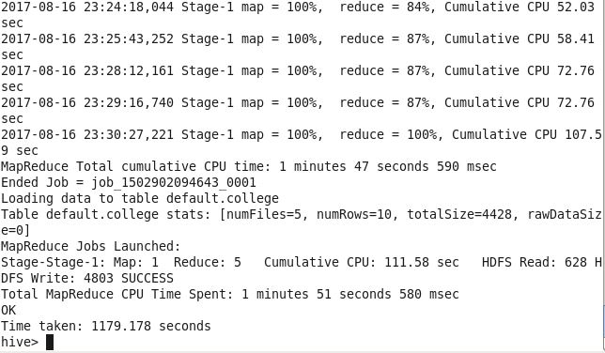

Data is inserted successfully, to check the data use below command.

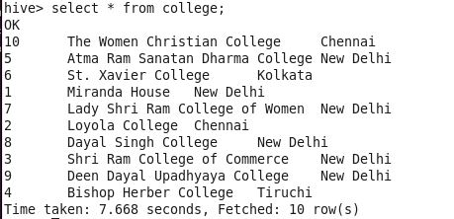

If above insert command is fired once more, then data will get appended to the table, refer below three screenshots:

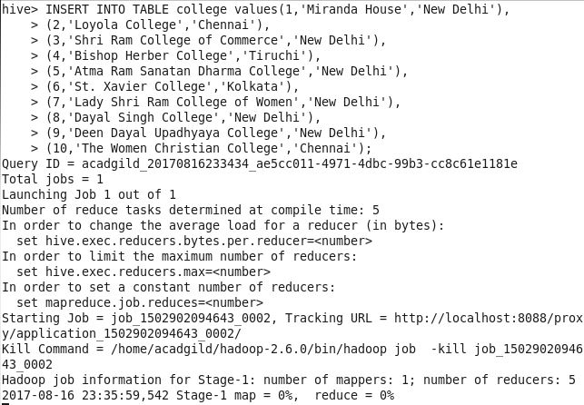

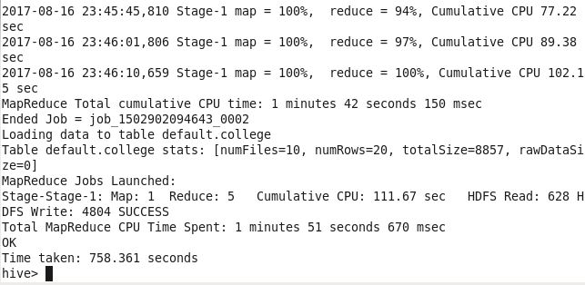

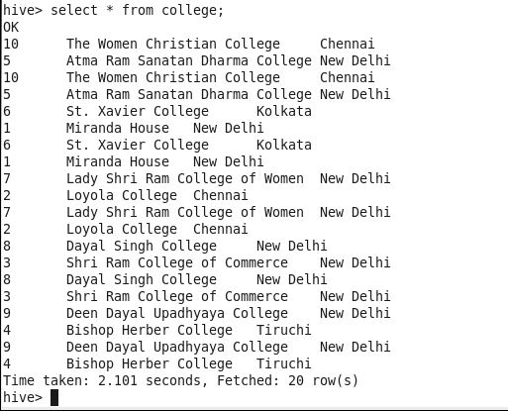

Output of above select command shows that data has got added in the “college” table

**Step 5: Updating the data in the Hive table “college”**

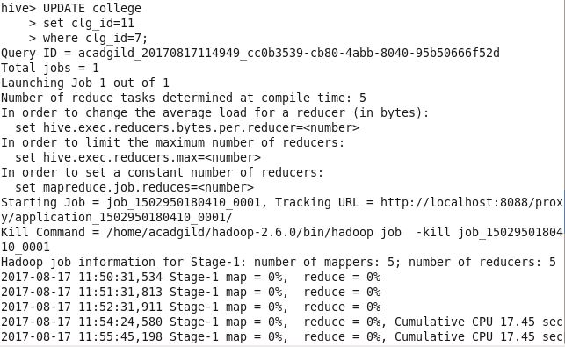**CASE 1: Updating bucketed column i.e. clg_id**

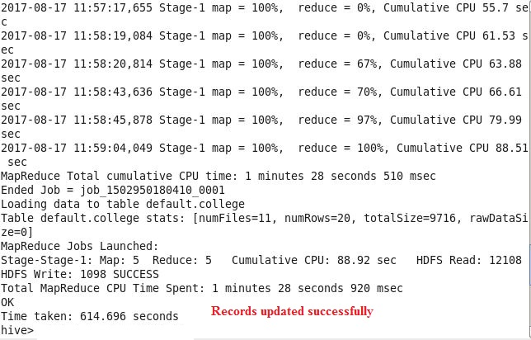

**Using select we can see records with clg_id=7 have been updated to clg_id=11**

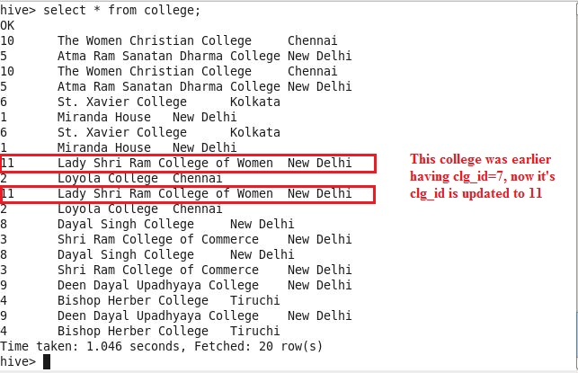

**Note: Above UPDATE command, updates all the rows with clg_id=7 to clg_id=11, however, it shouldn’t happen, because clg_id is bucketed column and update command is not supported for columns that are bucketed, so below error would have been returned:**

***FAILED: SemanticException[Error 10302]: Updating values of bucketing columns is not supported. Column clg_id***

**Below screenshot shows that buckets are created inside “college” table for “clg_id” column, still it allows update operation on this bucketed column**

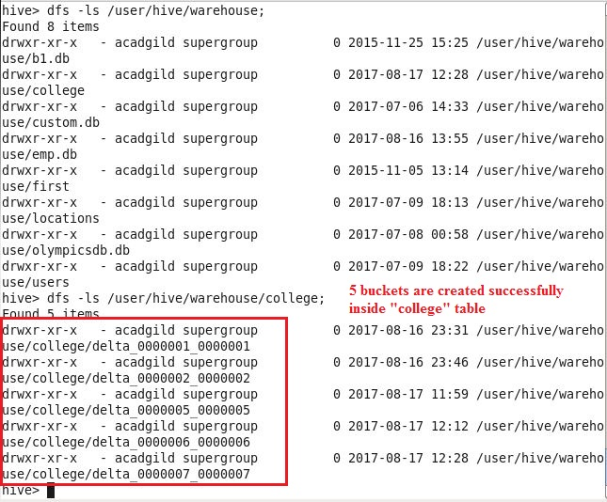

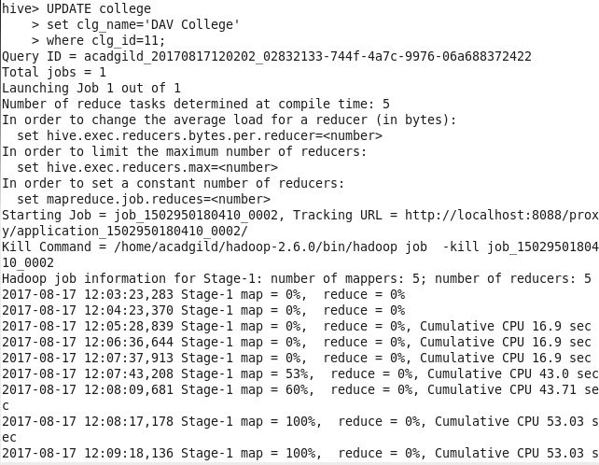**CASE 2: Updating non-bucketed column i.e. clg_name**

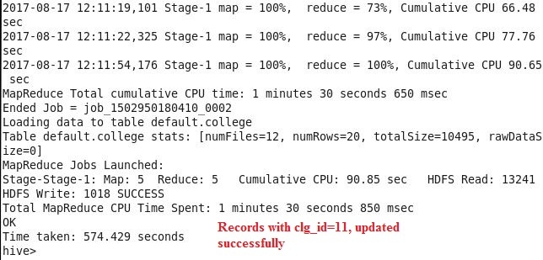**Using select command, we can see records with clg_id=11 have been updated with clg_name= ‘DAV College’**

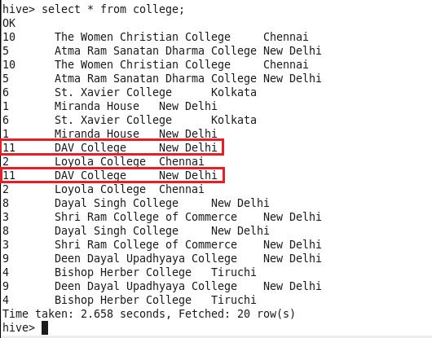

**Step 6: Deleting Row from Hive Table “college”**

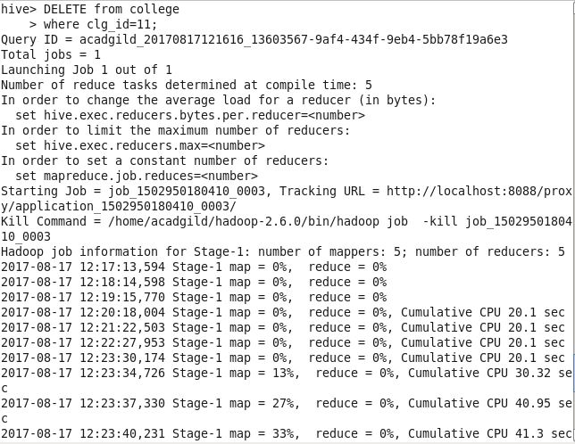

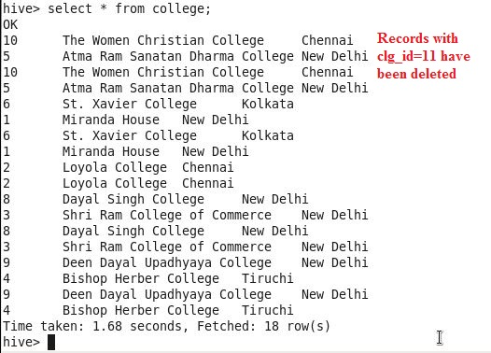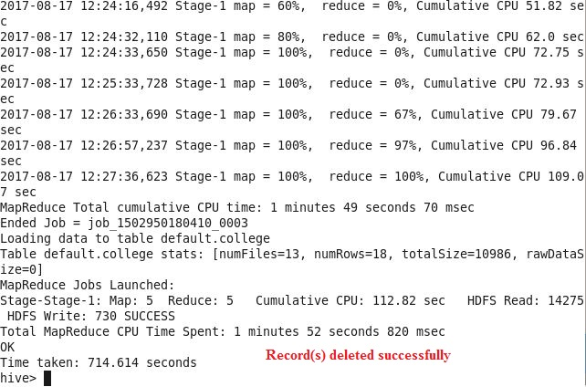**Using select command, we can see that records with clg_id=11 deleted successfully**